**RED ROVER INSTRUCTIONS**

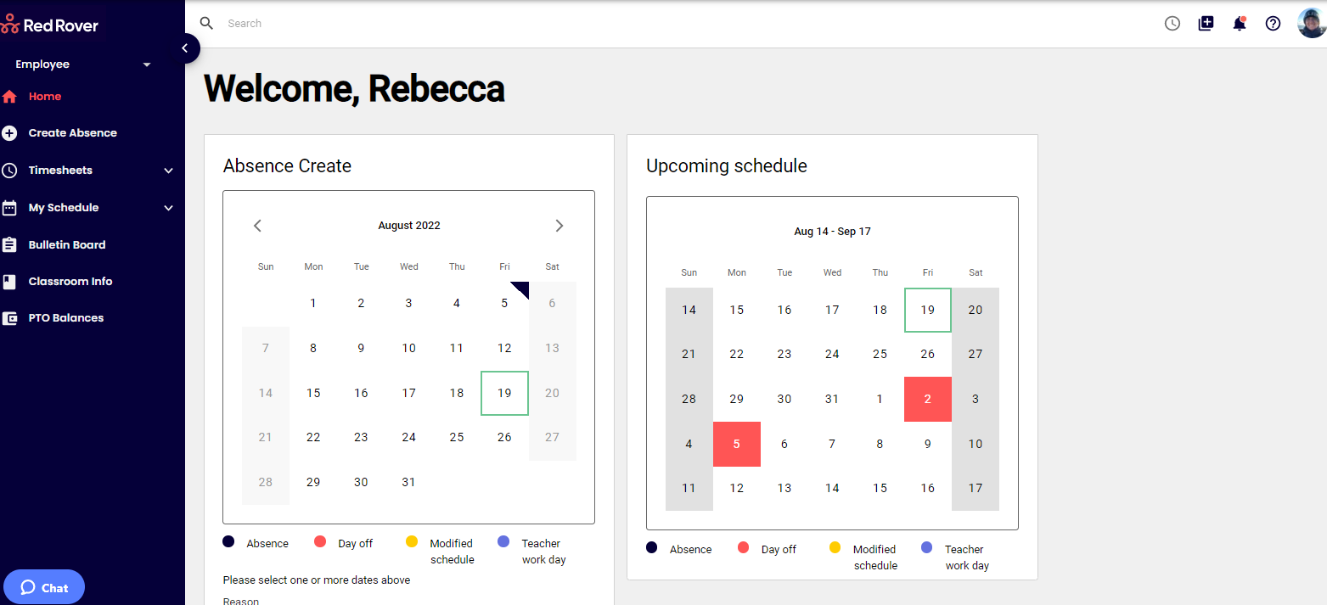

Create Absence = Creating your absence

Timesheets = To view timesheet and submit for payroll

PTO Balances = View current balances

**To create an absence:**

Select the day by clicking on it

Select a reason from the drop down

Select times either full or half day from the drop down

Hit CREATE

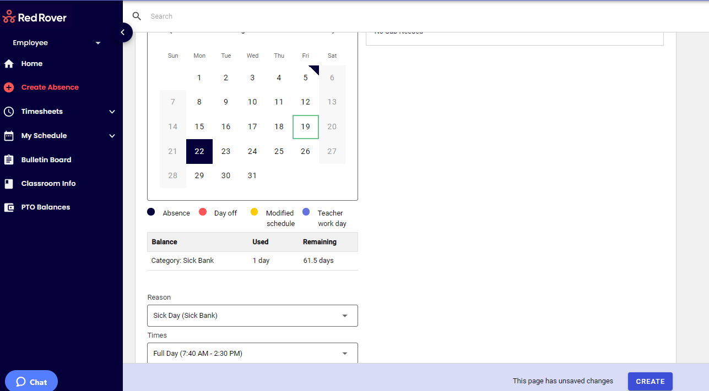

**To clock in and out on computer:**

Hit the clock in the right corner of screen

Click on Clock in or Clock out bar

A comment can be left if necessary

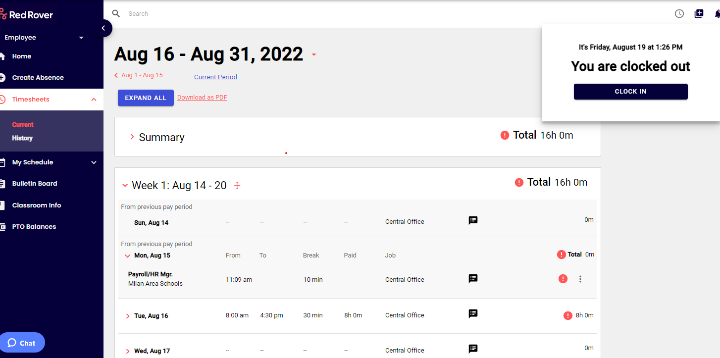

**To submit your time card:**

Review all entries for time period

Hit the SUBMIT button to approve your hours

